**《Fundamentals of Electric Circuits》homework CH.9**

**9.19 Using phasors, find:**

***(a) 3 cos(20t + 10°) - 5 cos(20t - 30°)***

***(b) 40 sin 50t + 30 cos(50t - 45°)***

***(c) 20 sin 400t + 10 cos(400t + 60°) - 5 sin(400t - 20°)*** *(20’)*

**9.42 Calculate *vo(t)* in the circuit of Fig.9.49.** (10’)

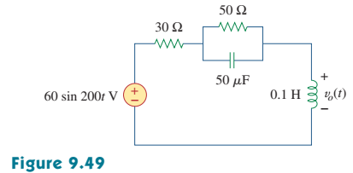

**9.44 Calculate *i(t)* in the circuit of Fig.9.51.** (10’)

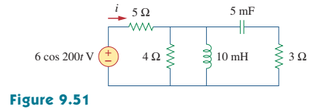

**9.52 IfV in the circuit of Fig.9.59, find *Is* .**  (10’)

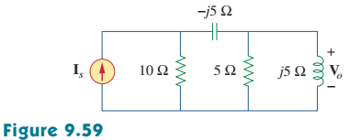

**9.67 At *ω = 103 rad/s,* find the input admittance of each of the circuits in Fig. 9.74.**

(20’)

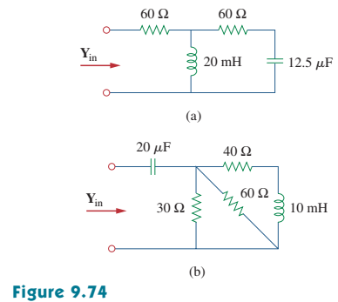

**9.80 Consider the phase-shifting circuit in Fig. 9.83. Let *Vi= 120 V* operating at *60 Hz*. Find:**

**(a) *Vo* when *R* is maximum**

**(b) *Vo* when *R* is minimum**

**(c) the value of *R* that will produce a phase shift of *45°.*** (30’)

